BSPD V2 2P

Two separate boards in accumulator and pedal box. Main board in pedal box monitors brake pressures and current sensor plausibility. Secondary board in accumulator monitors current sensor and sends digital plausibility signal to pedal box. All outputs to be buffered. Pulldowns on inputs and outputs. 5 V logic, onboard regulation where no nearby regulation available.

# Pinout Pedal box

* 12 V
* GND
* CURRENT_PLAUS
* BSPD_OK
* BPS1_SIG
* BPS1_PWR
* BPS1_GND
* BPS2_SIG
* BPS2_PWR
* BPS2_GND

# Pinout Accumulator

* 12/5 V
* GND
* CURRENT_SENSE
* CURRENT_PLAUS

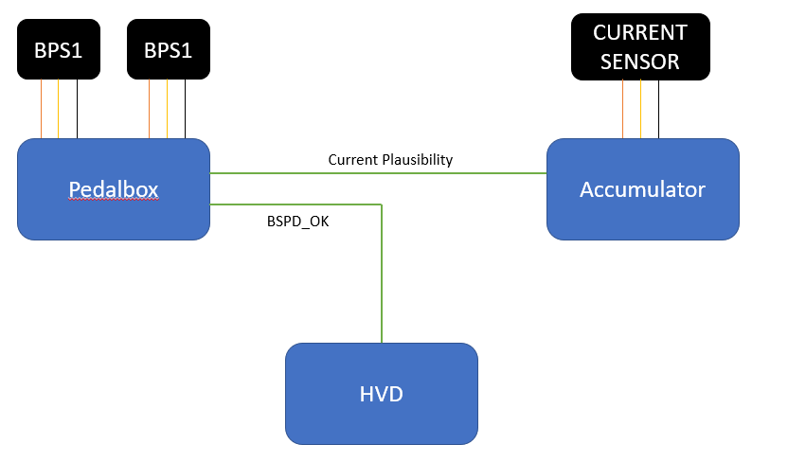

# Functionality

The two BSPD units function together to fulfil the BSPD rules **EV 8.7**.